Passive Buzzer Module

Overview：
This course will use the Arduino Uno to control the passive buzzer to beep.

Materials：
Arduino Uno x 1
Passive Buzzer Module x 1
DuPont wires x 3

Product description :
● Application: Active Buzzer is widely used in computers, printers, copiers, alarms, electronic toys, telephones and other electronic products.
● the differences between the Active Buzzer and Passive Buzzer: From exterior, the two buzzer seem to be the same. If the buzzer pin is faced up, there is a green circuit board on passive buzzer, on the contrary, active buzzer has no circuit board but is sealed by vinyl. In appearance, it is not absolutely possible to distinguish between active and passive. The most reliable method is not only to check the parameter manual of the product, but also to use a multimeter to test the buzzer resistance. Passive buzzer is 8Ωor 16Ω. Active buzzer are with a resistance of several hundred ohms or more.
● Function: The active buzzer can beep continuously by directly connecting with the rated power supply. And the passive buzzer is the same as the electromagnetic speaker, which needs to be connected to the audio output circuit to beep.

Technical Parameters ：
Working voltage: 3.5-5.5V
Working current: <25mA
PCB Dimension: 18.5mm x 15mm(L x W)

Wiring diagram:
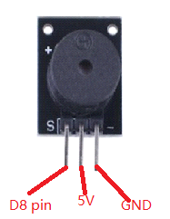
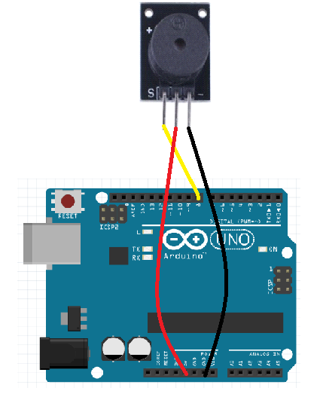

Example code:
int buzzer=8;// Set the control the buzzer digital IO pin
void setup()
{
pinMode(buzzer,OUTPUT);// Setting the digital IO pin mode , OUTPUT is Wen out
}
void loop()
{
unsigned char i,j;// Define the variable
while(1)
{
for(i=0;i<80;i++)// Wen a frequency sound
{
digitalWrite(buzzer,HIGH);// Sound
delay(1);//delay 1ms
digitalWrite(buzzer,LOW);//Not sound
delay(1);// delay 1ms
}
for(i=0;i<100;i++)// Wen out another frequency sound
{
digitalWrite(buzzer,HIGH);// Sound
delay(2);//delay 2ms
digitalWrite(buzzer,LOW);// Not sound
delay(2);//delay 2ms
}
}
}

Experimental phenomena：
Passive buzzer can play music.

